**High Impact Skills Development Program** **AI & Data Science**

**Name: Irshad Ali**

**Roll No: DSAI-GIL-203**

**Gmail:** [**irshadalirahi001@gmail.com**](mailto:irshadalirahi001@gmail.com)

**Title: Data Mining Project.**

**Profile link:** https://github.com/Irshad463/Irshad463

**Beginner Queries.**

Q1:        **Define meta data in mysql workbench or any other SQL tool**

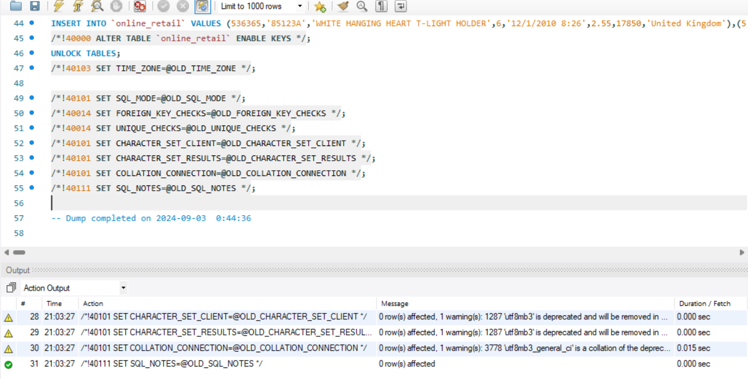

Q2:     **What is the distribution of order values across all customers in the dataset?**

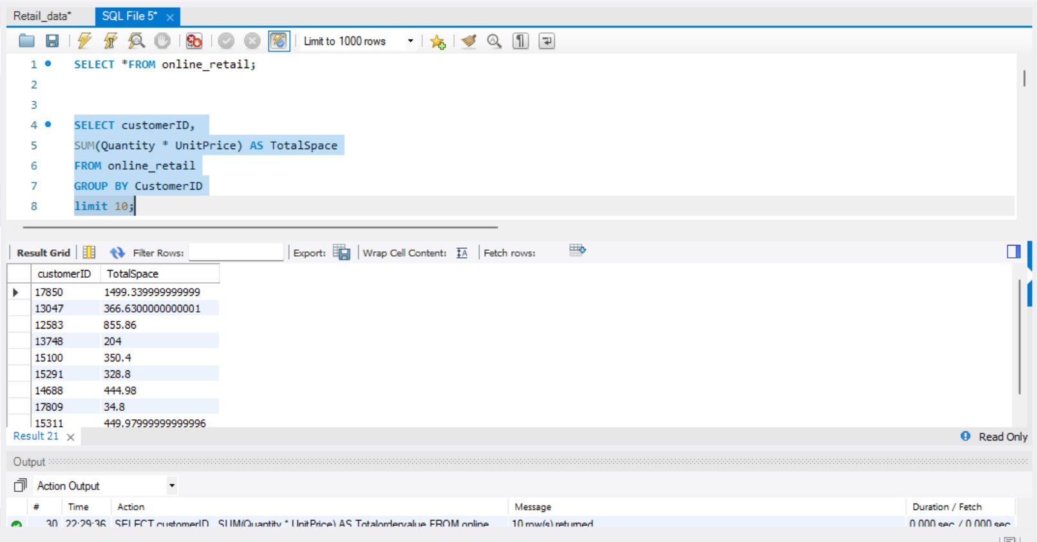

SUMMERY:

The SQL query determines the cumulative expenditure of each customer by aggregating the total cost of all products ordered.

**Q3    How many unique products has each customer purchased?**

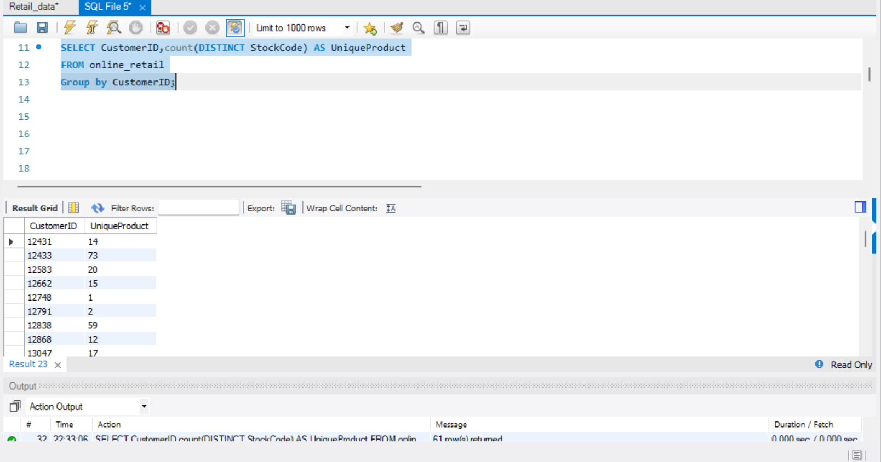

The query retrieves the number of distinct products purchased by each customer in the online_retail table. It groups the results by CustomerID and counts the distinct StockCode values, giving the total number of unique products purchased by each customer.

**Q4   Which customers have only made a single purchase from the company?**

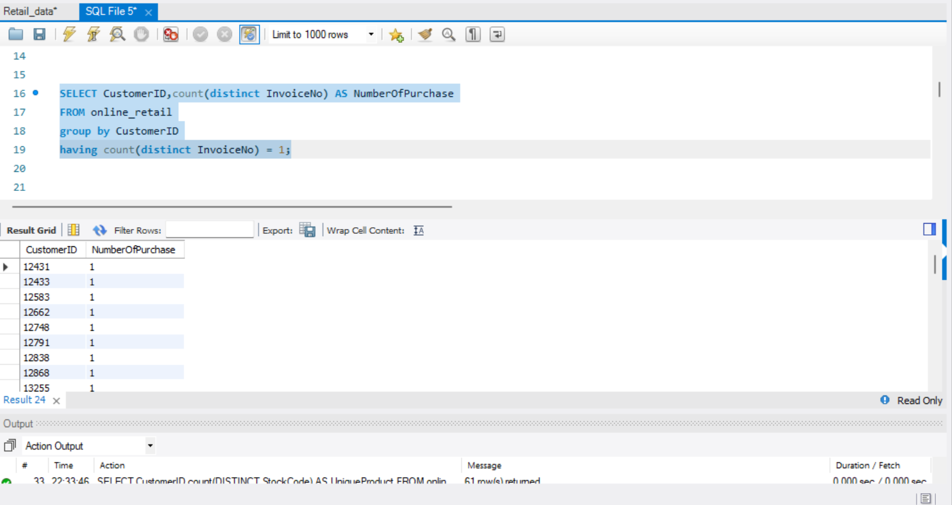

The SQL query is selecting the CustomerID and the count of distinct StockCodes, which is being aliased as "UniqueProduct", from the "online_retail" table. The query then groups the results by CustomerID. The result shows 10 rows with CustomerID and the number of unique products purchased by that customer.

**Q5     Which products are most commonly purchased together by customers in the dataset?**

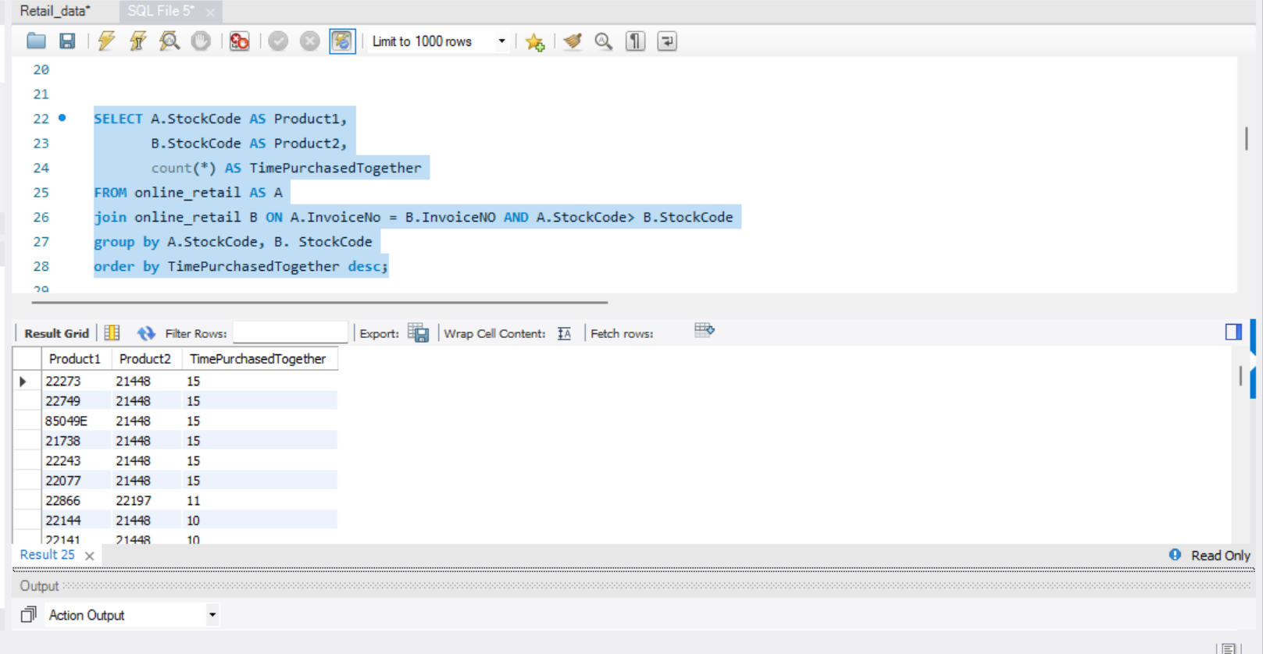

**Advance Queries**

**1.      Customer Segmentation by Purchase Frequency**

Group customers into segments based on their purchase frequency, such as high, medium, and low frequency customers. This can help you identify your most loyal customers and those who need more attention.

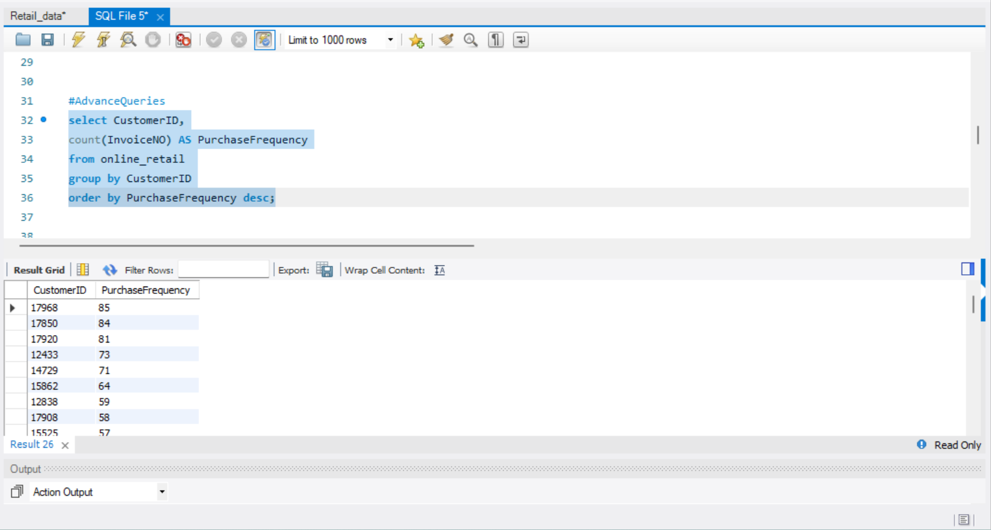

**2. Average Order Value by Country**

Calculate the average order value for each country to identify where your most valuable customers are located.

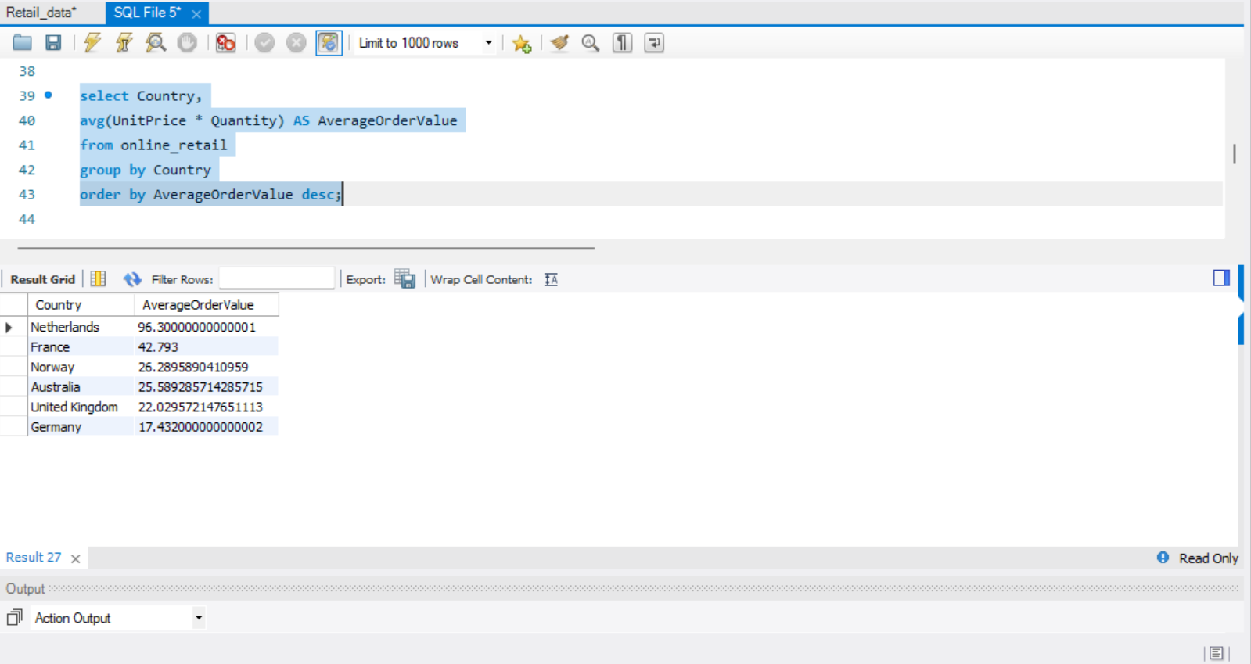

**3. Customer Churn Analysis**

 Identify customers who haven't made a purchase in a specific period (e.g., last 6 months) to assess churn.

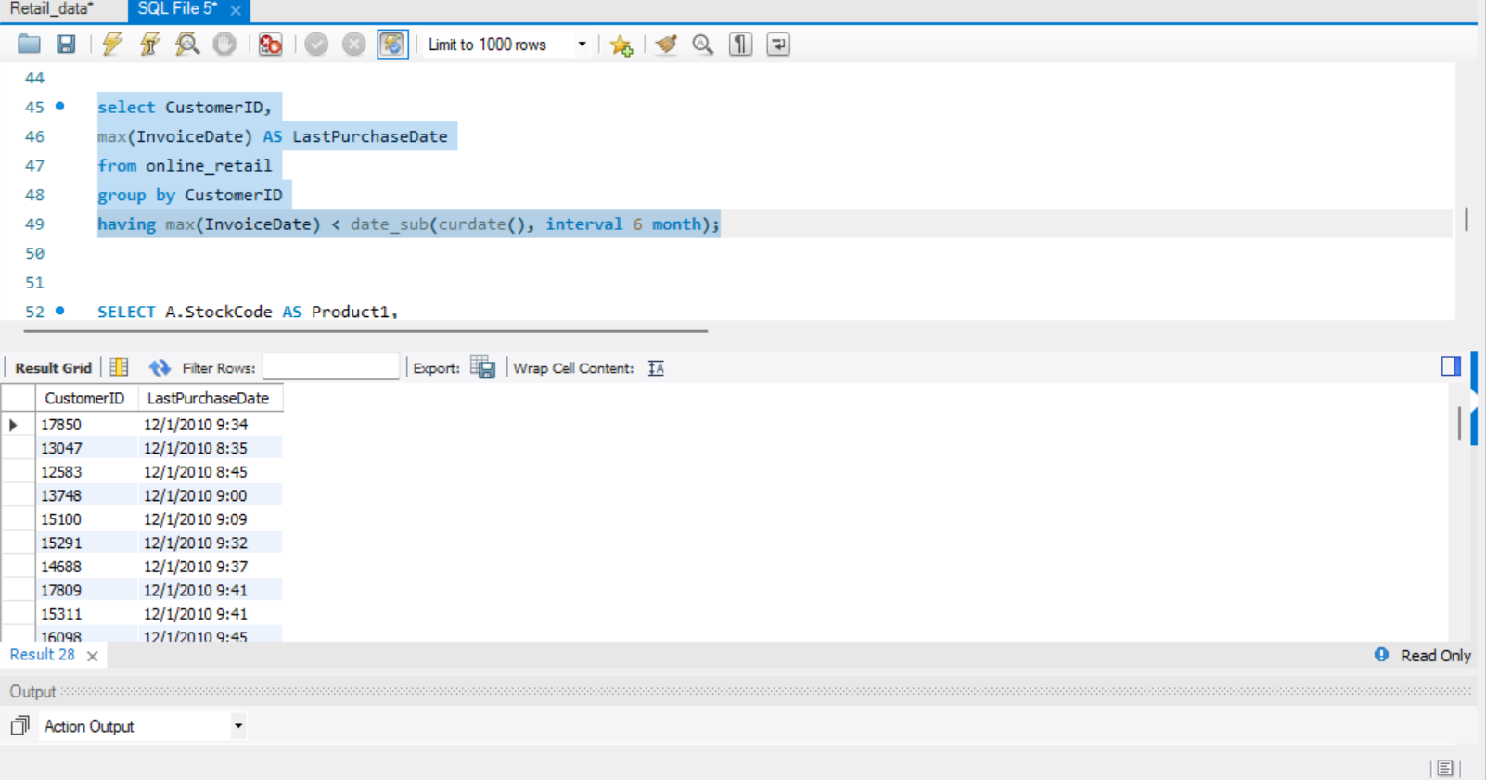

**4. Product Affinity Analysis**

Determine which products are often purchased together by calculating the correlation between product purchases.

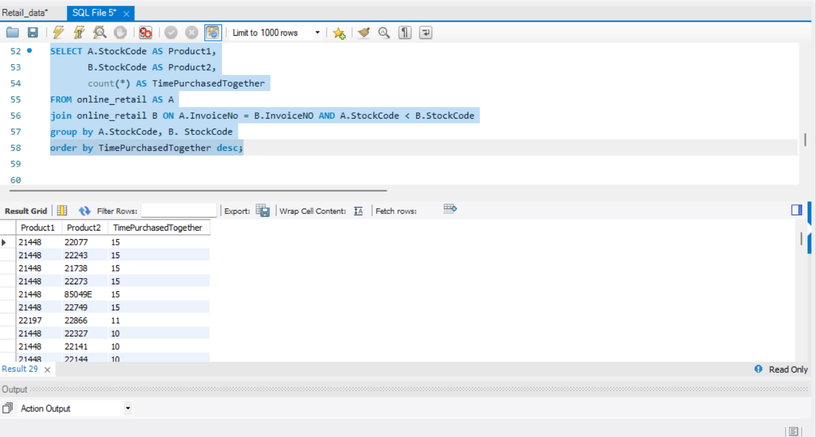

**5. Time-based Analysis**

  Explore trends in customer behavior over time, such as monthly or quarterly sales patterns.

